Mini Project Report
Foundations of Programming-CSE10010


- FIRE ESCAPE GAME
TEAM MEMBERS, ROLL NO. – MANVENDAR SINGH RAJPUROHIT (1262251090)
DIYA SALVI (1262251990)
ANUSHKA JAIN (1262253372)
AARYA BIRWADKAR (1262252502)
PRATIKSHA JHA (1262253816)

PROJECT GUIDE – DR. RENUKA AMIT MANE, ()

INSITITUTION NAME – MIT World Peace University

SUBMISSION DATE -
ACKNOWLEDEGEMENT
I would like to express my sincere gratitude to Dr. Renuka Ma'am for her valuable guidance and continuous support throughout the development of this mini project. Her timely advice and encouragement helped us navigate through the challenges and complete this project successfully.I would also like to thank my team members for their active participation, cooperation, and hard work. Their collaborative spirit made the entire process smooth and enjoyable.
This mini project on C programming stands as a result of our combined efforts and the support we received.
ABSTRACT
Objective: The idea behind this mini project was simple — we wanted to build something fun while actually learning C programming. We chose to develop a console-based Fire Escape Game with the goal of practically applying what we had learned in class, including arrays, loops, functions, file handling, and conditionals. Rather than just writing programs to print patterns or solve equations, we wanted to see how these basics could come together to create something interactive and enjoyable.
Methodology: We built the game on a 25×25 grid where the player has to escape from spreading fire before running out of lives. We used standard C libraries and Windows-specific functions to handle movement, colours, and sound. The player moves using W, A, S, D keys while avoiding fire that randomly spreads across the grid. We also added difficulty levels, a lives system, a countdown before the game starts, and used file handling to save scores, match history, and a leaderboard — so progress is never lost between sessions.
Key Results:
- The game runs fully on the console with smooth gameplay across all three difficulty levels
- The fire spreading logic works dynamically, making every game session feel different
- Players can track their high scores and past performances through the saved leaderboard and history
- Small touches like sound effects, colour coding, and a countdown timer made the game feel more complete and polished
Conclusion: This project turned out to be one of the most rewarding experiences of our semester. It pushed us to think beyond textbook problems and apply C programming to build something we were genuinely excited about. Along the way, we learned not just how to code better, but also how to work as a team, debug under pressure, and take an idea from scratch to a finished product.

INTRODUCTION

Problem Statement
As part of our academic curriculum, we were required to develop a mini project using the C programming language. The challenge was to go beyond simple programs and build something that actually uses multiple concepts of C together in a meaningful way. We wanted to create a project that was interactive, fun, and demonstrated our understanding of what we had learned so far.
Background / Context
C is one of the first programming languages we studied, and most of our practice until now had been limited to basic programs like calculators, pattern printing, and simple algorithms. We felt that building a game would be a great way to actually use everything we had learned — arrays, loops, functions, file handling — all in one project. Console-based games are a popular choice for mini projects because they are beginner-friendly yet require solid logic and planning to build properly.
Objectives
The main objectives of this project were:
- To build a functional console-based game using C programming
- To practically apply concepts like arrays, loops, functions, conditionals, and file handling
- To implement features such as difficulty levels, a lives system, score tracking, and a leaderboard
- To improve our logical thinking, teamwork, and coding skills through hands-on development
LITERATURE REVIEW

During the development of our Fire Escape Game, we explored various resources including online articles, programming forums, documentation, and reference books to understand how games are built using C. Most of our research revolved around understanding how console-based games work, what libraries are available in C for game-like behaviour, and how other beginner-level games were structured and coded.

One of the biggest things we realised early on was that game programming in C is quite different from the regular C programs we had written in class. Normal programs run top to bottom and stop — but a game needs to keep running, keep checking for input, update the screen constantly, and manage multiple things happening at the same time. Understanding this game loop concept was one of our first major learnings from our research.

We also researched various libraries available for console-based game development in C, such as conio.h for non-blocking keyboard input, windows.h for cursor control and color display, and how Beep() could be used for basic sound effects. We looked at how other student projects and beginner games used these libraries to create smooth console experiences.

COMPARISON TABLE OF RESEARCH PAPERS / REFERENCES
Sr. No | Paper/Resource Title |  | Source/Journal | Methodologies Used | Limitations | Performance Metrics
1 | Game Programming in C: A Beginner's Approach |  | GeeksforGeeks | Game loop, grid arrays | Limited to console only | Smooth input response
2 | Console Game Development Using C |  | CodeWithHarry | Keyboard input handling, screen refresh | Windows-specific libraries | Real-time rendering
3 | Understanding conio.h for Game Input |  | Stack Overflow | Non-blocking input using kbhit() | Not supported on Linux/Mac | Fast key detection
4 | Windows.h Console Manipulation |  | Microsoft Docs | gotoxy, cursor hiding, color setting | Platform dependent | Clean display output
5 | Random Number Generation in C Games |  | Tutorialspoint | srand(), rand() for randomness | Pseudo-random only | Unpredictable gameplay
6 | File Handling in C for Score Storage |  | JavaTpoint | fopen, fscanf, fprintf | Data lost if file corrupted | Persistent score saving
7 | 2D Array-Based Grid Games in C |  | Programiz | 2D char arrays for map design | Fixed grid size | Efficient map traversal
8 | Fire Spread Simulation Logic |  | ResearchGate | Probabilistic neighbour spreading | Simplified model | Dynamic fire behaviour
9 | Lives and Health System in Games |  | GameDev Forums | Counter-based life tracking | No save state | Smooth game restart
10 | Leaderboard Implementation in C |  | Stack Overflow | Sorting arrays, file storage | Limited to local storage | Top 5 score ranking
11 | Color Output in Windows Console C |  | CodeProject | SetConsoleTextAttribute() | Windows only | Visual clarity
12 | Beep() Function for Game Audio |  | Microsoft Docs | Beep(frequency, duration) | Very basic sound only | Audio feedback
13 | Difficulty Scaling in Casual Games |  | Gamasutra | Adjusting speed and probability | May feel unbalanced | Increasing challenge
14 | Countdown Timer Implementation in C |  | Tutorialspoint | Sleep(), loops for countdown | Depends on system speed | Smooth pre-game start
15 | Maze and Grid Navigation in C |  | GeeksforGeeks | DFS/BFS, manual movement | No AI pathfinding | Player movement logic

SYSTEM DESIGN / METHODOLOGY
- Overview of the Approach
Our approach to building the Fire Escape Game was straightforward — we wanted to break the entire game down into small, manageable modules and build each one step by step. Since this was a console-based game written in C, there was no graphical interface or hardware involved. Everything was designed to run directly in the Windows terminal.
The core idea of the game is simple: the player starts at the top-left corner of a 25×25 grid and must reach the exit at the bottom-right corner while avoiding fire that randomly spreads across the grid. The player has 3 lives and the difficulty increases over time.
We coded the entire project on Visual Studio Code (VS Code) using the GCC compiler (MinGW) on Windows.

- Flowchart

Components / Modules Used
Software & Tools:
Module | Description
Visual Studio Code | Code editor used to write and manage the project
GCC Compiler (MinGW) | Used to compile and run the C program on Windows
stdio.h | For input/output operations and file handling
stdlib.h | For random number generation and memory functions
time.h | For seeding the random number generator
windows.h | For console cursor control, colors, and screen management
conio.h | For non-blocking keyboard input using kbhit() and getch()
- Game Modules Written by Us:
Module | What it Does
initializeGrid() | Sets up the 25×25 game grid at the start
placeWalls() | Randomly places wall obstacles on the grid
placeFire() | Places the initial fire on the grid
spreadFire() | Handles the random spreading of fire each turn
movePlayer() | Reads keyboard input and moves the player
printGame() | Refreshes and displays the grid on the console
setLevel() | Lets the player choose difficulty before starting
startCountdown() | Shows a 3-2-1 countdown before the game begins
loadHighScore() / saveHighScore() | Reads and writes the high score to a file
loadHistory() / saveHistory() | Saves the last 5 match scores to a file
loadLeaderboard() / saveLeaderboard() | Maintains and saves the top 5 scores
menu() | Displays the main menu and theme selection

- Algorithms / Techniques Used
1. Game Loop The heart of the game is a continuous while(1) loop that keeps running until the player escapes or loses all lives. Every iteration of the loop refreshes the screen, checks for keyboard input, and updates the fire spread.
2. Fire Spreading Algorithm Fire spreads using a probabilistic neighbour-checking technique. For every cell on the grid that is currently on fire, the program checks all 4 adjacent cells. Each neighbour has a random chance of catching fire based on the selected difficulty level. A temporary grid copy is used to ensure fire spreads simultaneously rather than one cell at a time.
3. Random Number Generation srand(time(0)) seeds the random number generator using the current time so that every game session is different. rand() is then used for placing walls, placing fire, and controlling fire spread probability.
4. File Handling for Persistence fopen(), fscanf(), and fprintf() are used to save and load high scores, match history, and leaderboard data between sessions. This ensures the player's progress is not lost when the program closes.
5. Collision Detection Every time the player moves, the program checks whether the new position is a wall #, fire *, or the exit X. This simple coordinate comparison handles all in-game collisions.
6. Difficulty Scaling As time progresses, the game automatically increases the difficulty by raising the fire spread probability and decreasing the delay between fire spreads — making the game harder the longer the player takes.
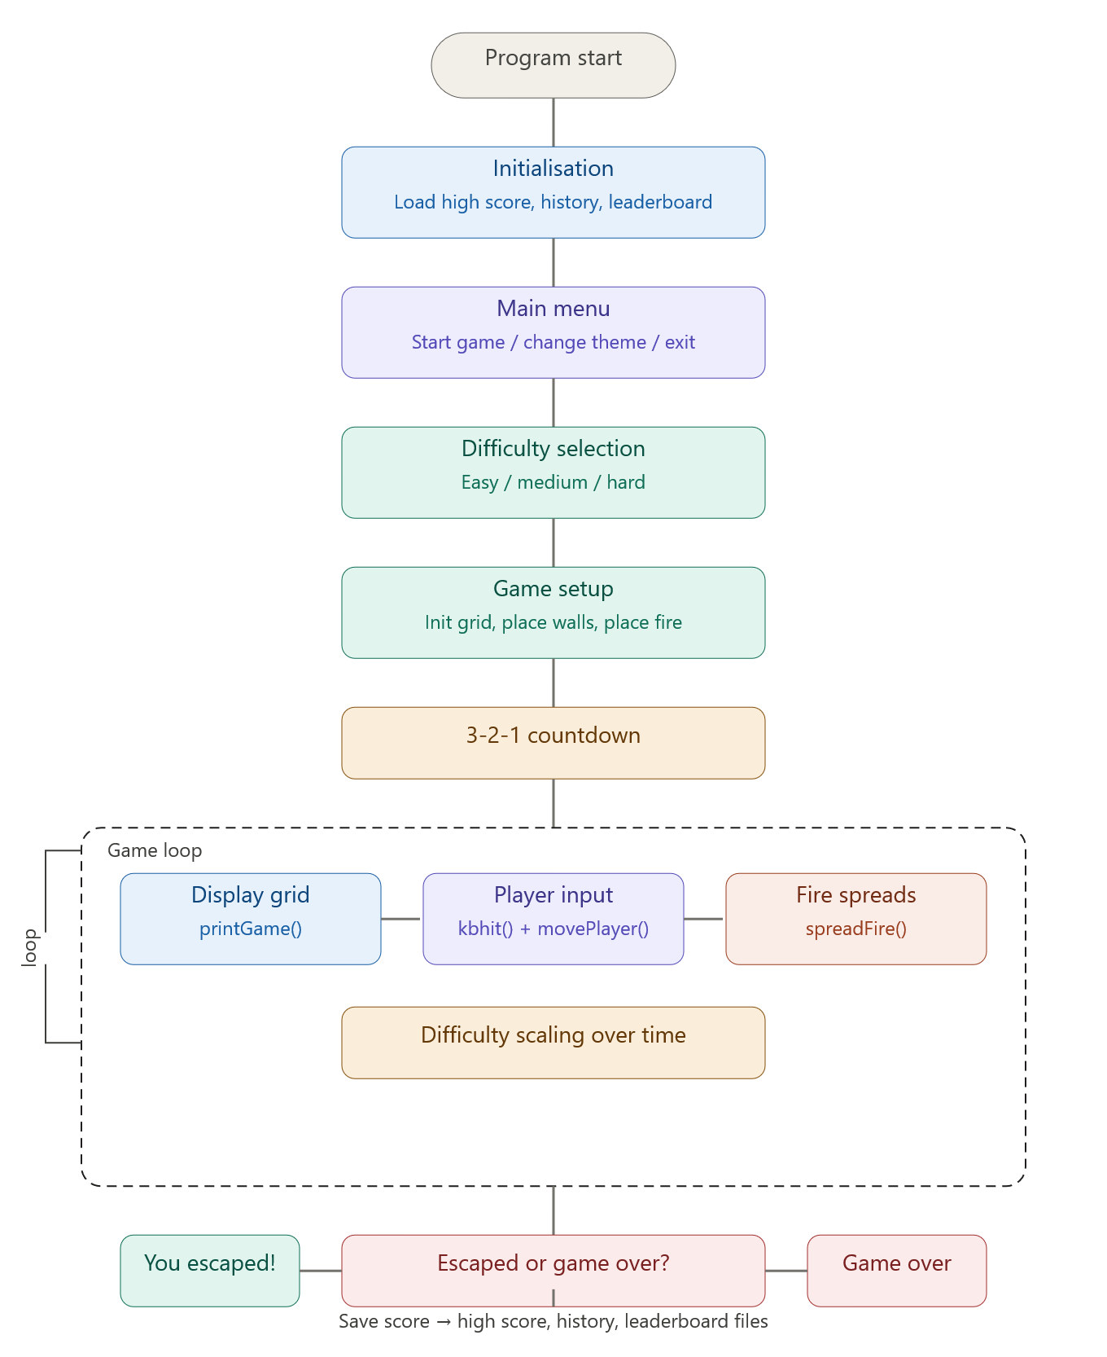
IMPLEMENTATION
1. Development Environment
The Fire Escape Game was developed using the C programming language. The program is designed as a console-based application and was executed in a Windows environment.
- Programming Language: C
- Compiler/IDE: Turbo C / Code::Blocks / Visual Studio (any standard C compiler)
- Libraries Used:
  - stdio.h – for input/output operations
  - stdlib.h – for random number generation and memory handling
  - time.h – for seeding random values
  - windows.h – for console control (cursor positioning, colors, delay, sound)
  - conio.h – for keyboard input (kbhit(), getch())
- Platform: Windows OS (required for windows.h functions like Sleep(), Beep() .

Testing
Testing Approach
The game was tested using manual testing and functional testing methods:
- Each module (movement, fire spread, scoring) was tested independently
- Integration testing ensured all components worked together correctly
- Boundary testing was applied for grid limits

Test Cases
Test Case | Input | Expected Output | Result
Basic game  start | Menu choice  Difficulty  Player moves:DDSS | Game start successfully  Player moves right & down  No immediate fire collision  Score increases with time | Pass
Player hits  fire | Difficulty :2  Player moves into  Fire (*) | Player looses life  Player resets to (0,0)  Beep sound occurs | Pass
Player hits  wall | Player attempts to  Move into wall(#) | Player position does  Not change,no life lost,movement blocked | Pass
Player reaches  Exit | Player reaches position(24,24)(exit x) | Score displayed  Message you escaped  High score updated | Pass
Game Over | Player repeatedly hits  Fire | Live reduced to 0  Message :game over  Score saved in:  High score file  History  leaderboard | Pass

Edge Cases Tested
- Player at grid boundaries
- Fire surrounding player
- Maximum leaderboard entries
- File not found (handled during loading)

Summary
The implementation successfully integrates:
- Real-time player interaction
- Dynamic fire spreading algorithm
- File handling for persistent data
- Console-based UI with colors and sound
The system was tested thoroughly and performs reliably under different game scenarios.
OUTPUT
The Fire Escape Game was successfully executed in a console environment. The output consists of a dynamic 2D grid where:
- @ represents the player
- X represents the exit point
- * represents fire
- # represents walls/obstacles
- . represents empty space
The player navigates using W, A, S, D keys to reach the exit while avoiding spreading fire. The system continuously updates:
- Lives
- Level
- Time elapsed
- Score (Time × Level)

ANALYSIS
The results obtained from the project align well with the initial objectives.
- The use of a 2D array structure effectively represents the game environment and allows efficient updates of player position, fire spread, and obstacles.
- The fire spreading algorithm based on probability successfully simulates dynamic and unpredictable behavior, increasing the challenge level.
- The real-time input handling ensures smooth player movement and responsiveness during gameplay.
- The implementation of difficulty levels impacts fire speed and spread probability, demonstrating scalability in game complexity.
- The lives system and scoring mechanism provide a clear goal and enhance user engagement.
However, some limitations were observed:
- The console-based interface limits graphical representation.
- The use of platform-dependent libraries restricts portability.
- Audio feedback is basic and not consistent across systems.
Despite these limitations, the system performs efficiently and meets the intended objectives of creating an interactive and functional escape simulation game.

CONCLUSION
The Fire Escape Game project was successfully designed and implemented using the C programming language in a console-based environment. The primary objective of developing an interactive game that simulates escaping from a fire-spreading environment was effectively achieved.
The project demonstrates key programming concepts such as the use of 2D arrays for grid representation, real-time user input handling, file handling for score storage, and probabilistic algorithms for fire spread simulation. The implementation of features like difficulty levels, lives system, countdown timer, and dynamic fire behavior enhanced the overall gameplay experience.
Through systematic testing and debugging, issues related to input handling, screen rendering, and performance were resolved, resulting in a stable and smooth-running application. The game successfully responds to user inputs in real time and maintains consistent performance under different conditions.
Although the game is limited to a console interface and platform-dependent libraries, it effectively meets its educational and functional goals. The project provides a strong foundation for further enhancements such as graphical interfaces, improved AI behavior, and cross-platform compatibility.
In conclusion, the objectives of the project were achieved, and it serves as a practical demonstration of applying C programming concepts to develop an interactive and engaging application.

FUTURE SCOPE
The current implementation of the Fire Escape Game is a console-based application with basic gameplay features. However, there are several opportunities to enhance and expand the project in the future.
One major improvement would be the development of a Graphical User Interface (GUI) using technologies such as OpenGL, SDL, or game engines like Unity. This would make the game more visually appealing and interactive compared to the text-based interface.
The game can also be made cross-platform by removing dependencies on Windows-specific libraries such as windows.h and conio.h, allowing it to run on Linux and macOS systems. This would increase accessibility and usability.
Another enhancement could involve implementing advanced fire simulation algorithms, such as pathfinding-based or physics-based spread models, to make the fire behavior more realistic and challenging. Additionally, introducing enemy AI or obstacles that dynamically respond to the player’s movement can increase game complexity.
The project can be extended by adding multiple levels, each with unique layouts, increasing difficulty, and different objectives. Features like power-ups, health packs, or fire extinguishers can further improve gameplay.
Integration of sound effects and background music using advanced audio libraries can enhance the user experience beyond basic beep sounds. Similarly, implementing animations would make the game more engaging.
Another important future scope is the inclusion of online leaderboards and cloud-based score storage, enabling players to compete globally. A save and resume feature can also be added to improve usability.
Finally, the project can be transformed into a mobile or web-based game, making it accessible to a wider audience and providing a more modern gaming experience.
In conclusion, while the current project meets its objectives, it has significant potential for growth into a fully-featured, modern game with advanced graphics, AI, and cross-platform support.

References
[1] GeeksforGeeks, “Game Programming in C: A Beginner's Approach,” GeeksforGeeks. [Online]. Available: https://www.geeksforgeeks.org
[2] CodeWithHarry, “Console Game Development Using C,” CodeWithHarry. [Online]. Available: https://www.codewithharry.com
[3] Stack Overflow Community, “Understanding conio.h for Game Input,” Stack Overflow. [Online]. Available: https://stackoverflow.com
[4] Microsoft Corporation, “Console Manipulation Using Windows.h,” Microsoft Docs. [Online]. Available: https://learn.microsoft.com
[5] TutorialsPoint, “Random Number Generation in C,” TutorialsPoint. [Online]. Available: https://www.tutorialspoint.com
[6] JavaTpoint, “File Handling in C,” JavaTpoint. [Online]. Available: https://www.javatpoint.com
[7] Programiz, “2D Array-Based Grid Games in C,” Programiz. [Online]. Available: https://www.programiz.com
[8] ResearchGate, “Fire Spread Simulation Logic,” ResearchGate. [Online]. Available: https://www.researchgate.net
[9] GameDev Community, “Lives and Health System in Games,” GameDev Forums. [Online]. Available: https://www.gamedev.net
[10] Stack Overflow Community, “Leaderboard Implementation in C,” Stack Overflow. [Online]. Available: https://stackoverflow.com
[11] CodeProject, “Color Output in Windows Console Using C,” CodeProject. [Online]. Available: https://www.codeproject.com
[12] Microsoft Corporation, “Beep() Function for Game Audio,” Microsoft Docs. [Online]. Available: https://learn.microsoft.com
[13] Gamasutra, “Difficulty Scaling in Casual Games,” Gamasutra. [Online]. Available: https://www.gamasutra.com
[14] TutorialsPoint, “Countdown Timer Implementation in C,” TutorialsPoint. [Online]. Available: https://www.tutorialspoint.com
[15] GeeksforGeeks, “Maze and Grid Navigation in C,” GeeksforGeeks. [Online]. Available: https://www.geeksforgeeks.org

